Chapter 5, Problem 13

Find v_{o} and i_{o} in the circuit of Fig. 5.52.
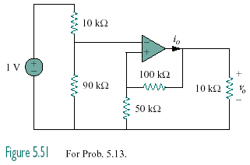

Figure 5.52
For Prob. 5.13.

